# **Historical Events: King Leopold and the Congo Free State**

# **Name:**

*Instructions:* Read the event(s) assigned to your group and answer the questions that follow. Be prepared to share your answers with the class.

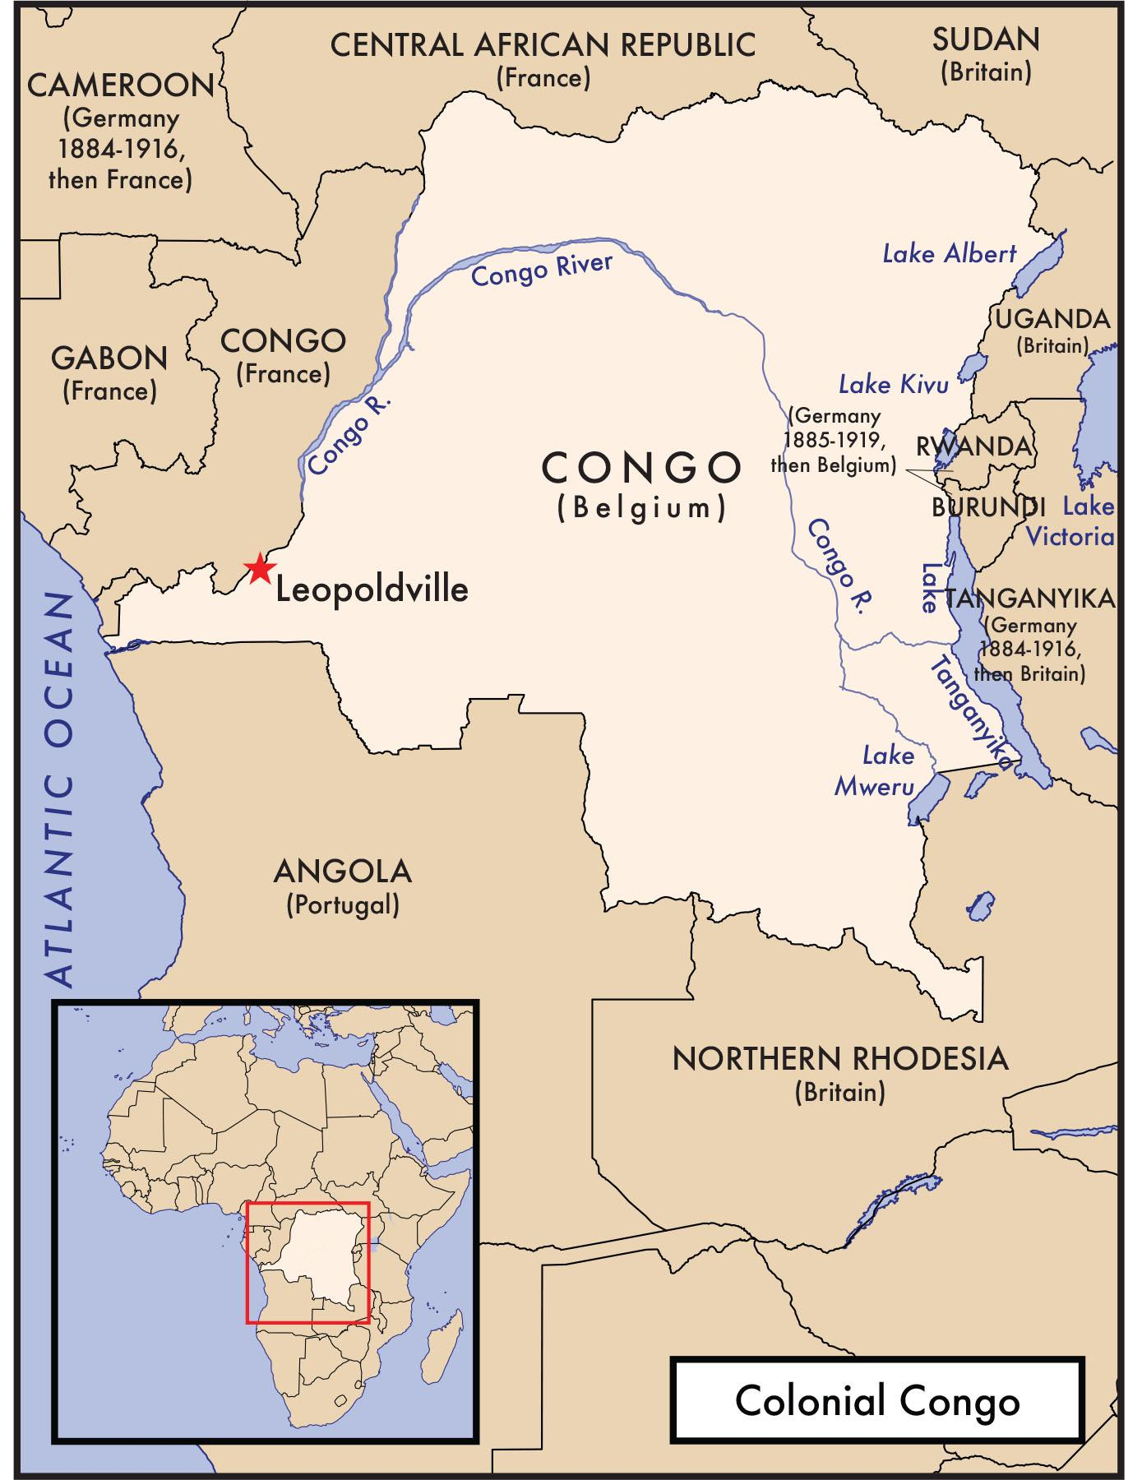

***Note on Disturbing Content***

*This reading contains content that may be upsetting for readers. It describes physical and psychological violence, and might be particularly intense for students with a personal connection to the topic. It is important to be sensitive to your classmates and the ways in which this might be a difficult topic to study.*

The region that is today the Democratic Republic of the Congo became the personal colony of King Leopold II of Belgium in 1885. The Congo Free State measured more than seventy-six times the size of Belgium. Its population of more than twenty million was diverse, with approximately 250 different ethnic groups.

Leopold’s top priority was to make money from his venture, the Congo Free State. Colonial officials constructed an economy based on the export of rubber and ivory to Europe. These goods were produced by the forced labor of Africans. In 1901 alone, six thousand tons of rubber left the colony. Colonial officials required Africans to meet daily quotas, and when people did not collect enough rubber, officials inflicted brutal punishments. Officials used rape, mutilation, and murder as punishment and as a way to control native Congolese. When communities rebelled, officials often killed all the inhabitants. Because they were forced to collect rubber, Congolese could not hunt or tend to their own crops, which resulted in widespread starvation. As many as ten million Congolese died in the first two decades of colonialism, largely as a result of abuses by Leopold’s colonial officials.

Colonial administrators also destroyed parts of Congolese culture. Officials took orphaned children away from their communities to work in “child colonies” or to train as soldiers. Colonial laws prevented Africans from traveling freely across provincial borders, or from practicing non-European religions. In addition to collecting ivory and rubber, Africans were forced to grow crops such as cotton, coffee, and tea for export. They were prohibited from selling harvested products to anyone other than European colonizers or a few powerful companies. Discoveries of precious metals and minerals such as cobalt, gold, copper, and diamonds led to the further extraction of Congo’s resources for European profit.

Colonial officials forced many Africans to work for the Force Publique, a police force that maintained control by intimidating and abusing local populations. Members of this force were subject to poor pay, brutal working and living conditions, and violent abuse at the hands of their Belgian officers.

As the international community became aware of the abuses of the Congo’s colonial system under King Leopold, public pressure forced Leopold to hand over the Congo to the Belgian government, which took control in 1908.

**Questions**

1. Were King Leopold and colonial officials’ actions in the Congo a genocide? Give at least two reasons from the text to support your view.

2. What standards from Article II of the Genocide Convention apply to determine if this event was a genocide?

3. What additional information would you like to have about King Leopold and the Congo Free State?